

ITP REPORT

GROUP MEMBERS

* Muhammad Haseeb Ahmad
* Mohammad Abdul Rafay
* Haad-bin-Abdul Maailk

Registration Number

* BSE183010
* BSE183009
* BSE183013

Section

4

Submitted To

Dr. Tanvir Afzal

o IOSTREAM (HEADER FILE)

# include is a preprocessor directive that enables a given header file to enter in the code. Say iostream it is header file with name iostream and .h indicates its type i.e header file. When we write :- #include<iostream> in C++ we can use the functions and macros defined in the header file directly like cout, cin & other basic input and output functions. #include<iostream> is used in C++ in order to include the header file “iostream” in the program. Iostream is used to invoke the commonly used functions like cout, cin in a C++ program. Iostream stands for input output stream.

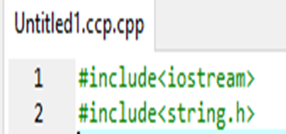

Figure 1:Figure 1: Iostream Header file

Iostream is a standard define function that contain all the important all the use full statement that are used in the program it also contain the statements for cout and cin as well.

The statement cin>> is used to enter the value or get the value from the user and store the value in the variable that is created in the RAM. The syntax **of cin>>** is cin>>” statements ” . For example

* String.h Header File:

C Programming/string.h. string.h is the header in the C standard library for the C **programming language** which contains macro definitions, constants and declarations of **functions** and types used not only for string handling but also various memory handling functions; the name is thus something of a misnomer. String.h header file is terminated when we press enter key and it automatically stores “\0” at the end.

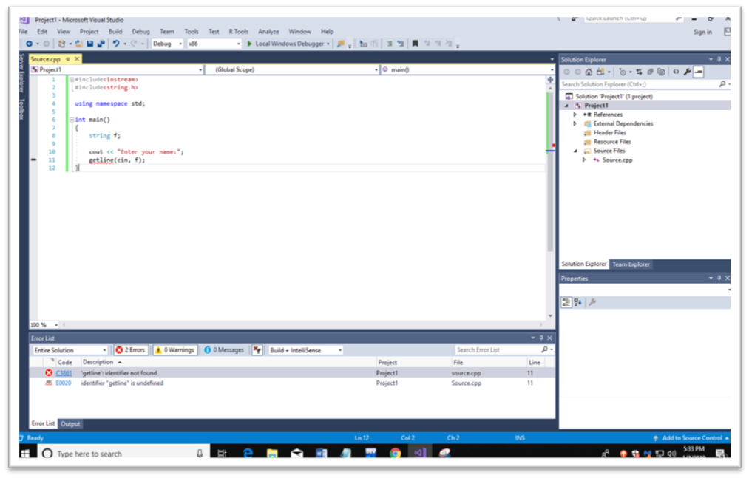

Figure 2:: Getting name from the user using string

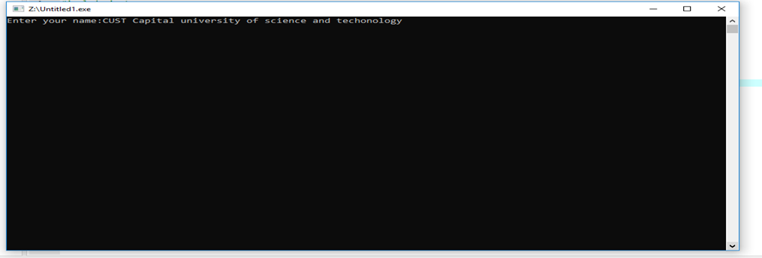

Figure 3:Output of program using string

* COUT<<

The statement cout<< is used to display all the values on the output screen. The syntax of cout<< is cout<<” statements ” and also displays the value which is stored in the variable cout<<; inside the statement we can display any message or any output on the screen. **For example**

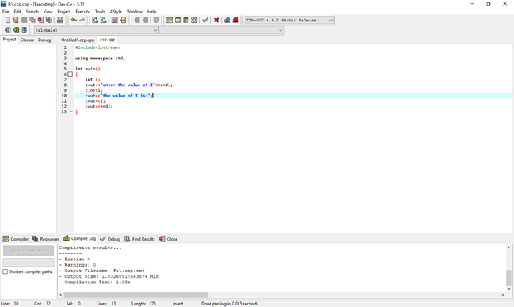

Figure 4:Using of cout<<

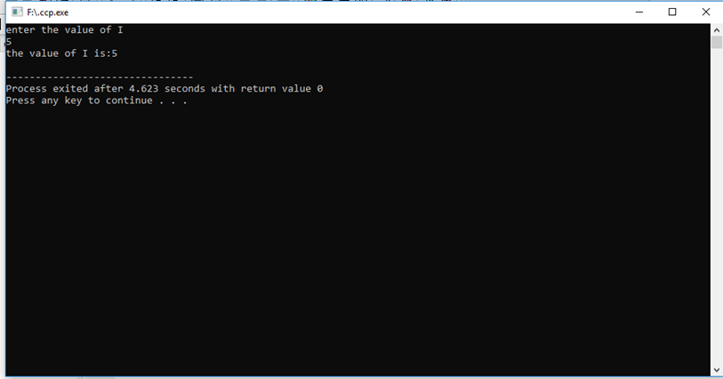

Figure 5:Output of cout<<

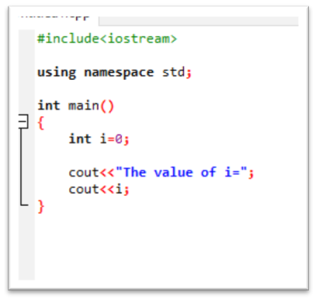

Figure 6:Printing the value of integer

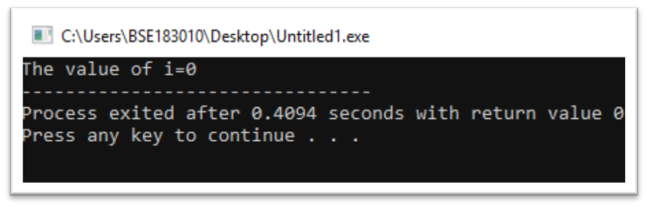

Figure 7:Printing the value of integer

* Cin>>

The statement cin>> is used to enter the value or get the value from the user and store the value in the variable that is created in the RAM. The syntax of cin>> is **cin>>” statements ”** . For example

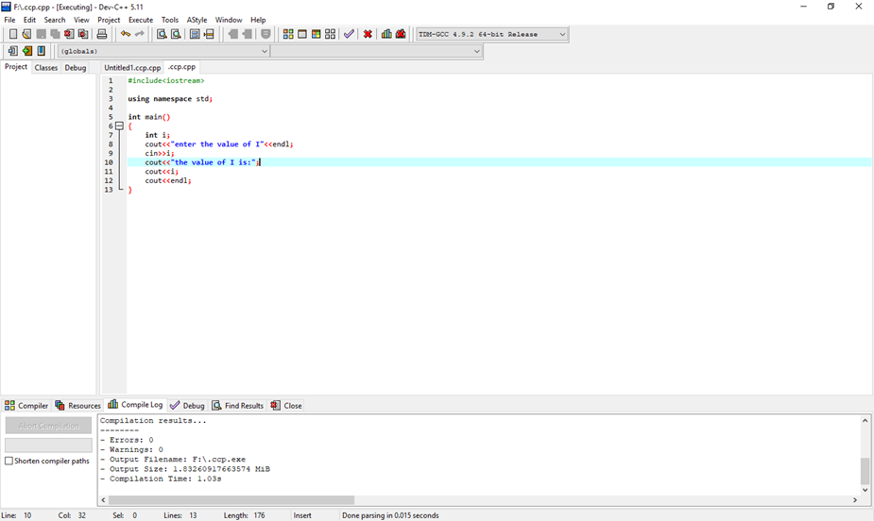

Figure 8: Getting the value using cin>>

* **Using namespace std :**

A namespace is a form of scope in C++ that holds its own definitions for variables, functions, etc. For example, both cout and cin, along with some useful tokens like endl, are defined inside of std for use. As a result, there are two primary ways to access them.

* Use of “using namespace std”:

A namespace is a declarative region that provides a scope to the identifiers (the names of types, functions, variables, etc inside it. Namespaces are used to organize code into logical groups and to prevent name collisions that can occur especially when your code base includes multiple libraries. 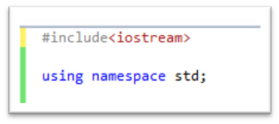

Figure 9:Using namespace std in a program

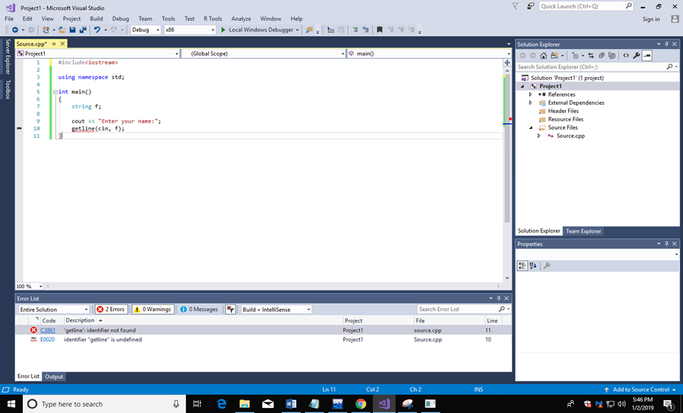

Figure 10:Figure 4: program containing using namespace std

* Functions

When group of line are written in a group and then Call in the main then it is called a function. There are two type of function a user define function and system base function or it is also known as the built in function. The built in function are iostream , conion.h etc where as the user define function can have any name according to the user desire .

In this program we will use different user define function which are given below:

* display_board()
* check_win()
* player_turn 1()
* player_turn 2()

In every type of function we write a lot of instruction and when it is need it is called when those instructions are need.

* **Void display_board():**

This is a user defined function which is always declared outside the main. In this function we are going to display the board which stores the values after receiving from the user on that certain index. We have declared the global variable which is excess able of all the functions in the program. After receiving the values from the other function it will display the board again and prints the “X” or “O” on that certain index.

We have declared the function outside the main as shown in the figure below:

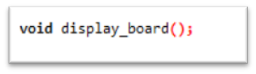

Figure 11:User defined function

The body of the void display_board() function is declared outside the main and is shown as below:

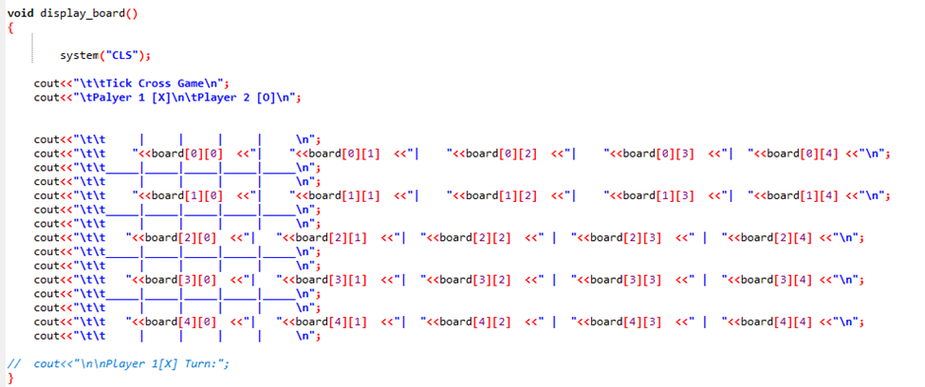

Figure 12:Defining the function void display_board() outside the main

We are calling the function in the main by writing as shown in the figure below:

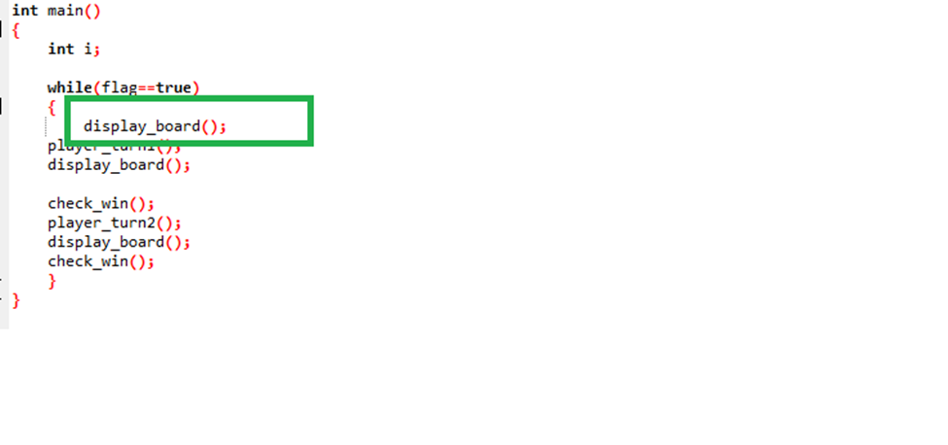

Figure 13:Calling the function in the main

o Void check_win():

This function is used to check whether the player 1[X] wins or whether player 2[O] wins. We have used the if as a conditional statement in which we have written that when the player 1 [X] or player 2 [O] wins.

We have declared the function outside the main as shown in the figure below:

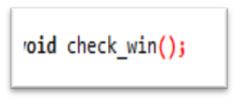

Figure 14:Definning the function outside the main

The body of the void check_win() function is declared outside the main and is shown as below:

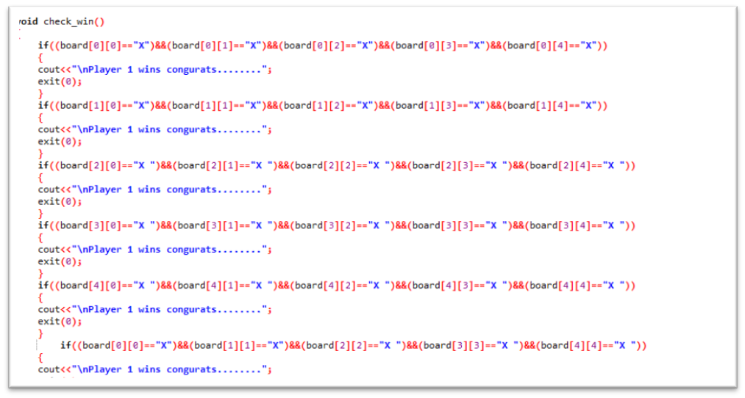

Figure 15:Defining the user defined function outside the main

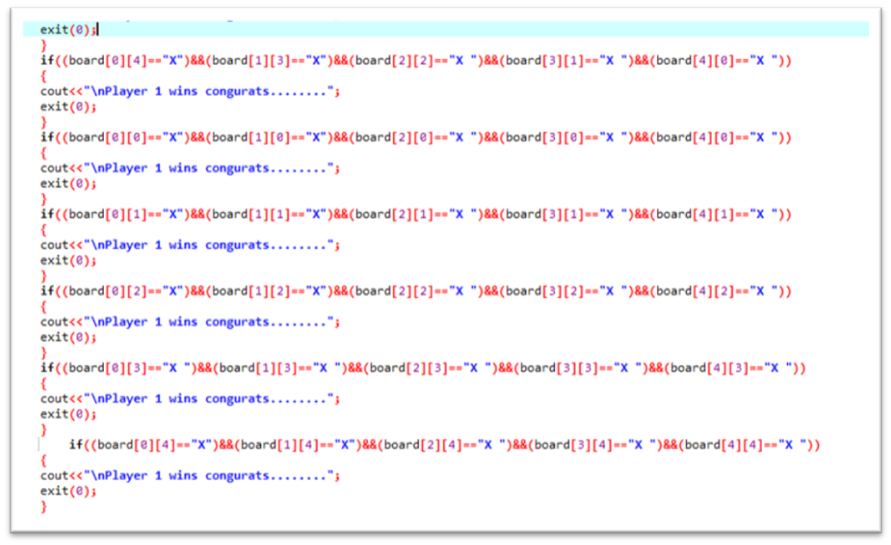

Figure 16:Defining the function outside the main

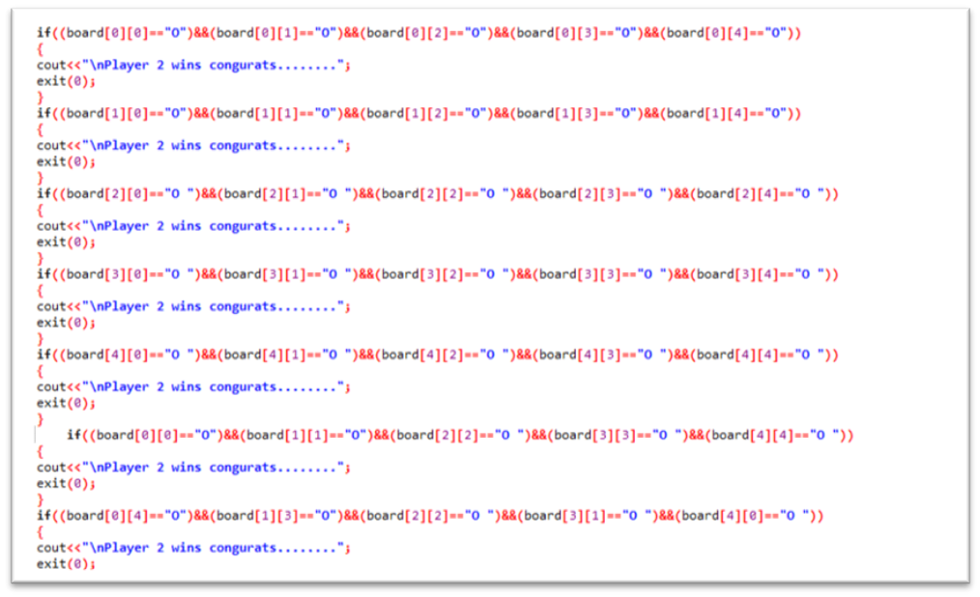

Figure 17:Defining the function outside the main

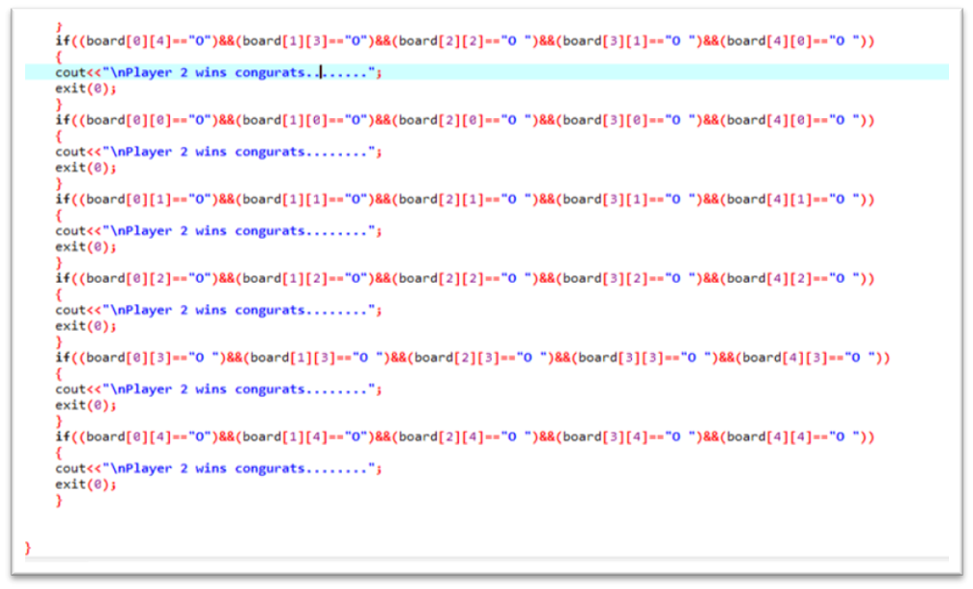

Figure 18:Defining the function outside the main

We are calling the function in the main by writing as shown in the figure below:

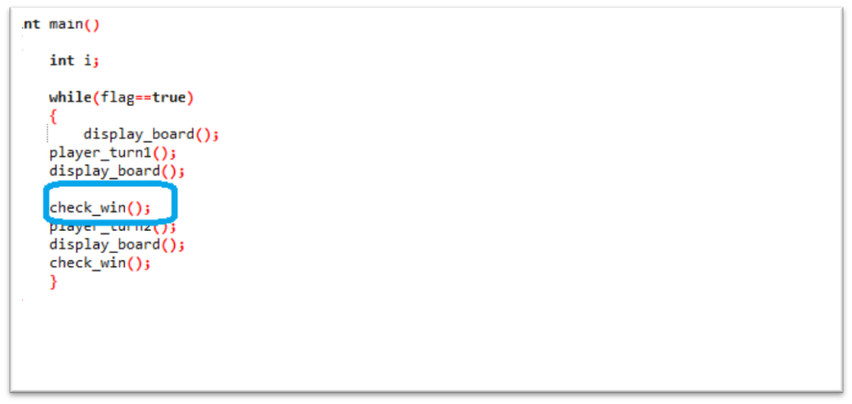

Figure 19:Calling the function in the main

o Function Player_turn 1

This is the user define function that is used in the making of Tick Cross Game. This type of function is used to decided where the input value is store. For this function we are going to use Switch statement and there are total 25 cases that will decide where the user will input the value and replace the value the numerical value with the Symbol “X”. In order to get again and again the value from the user we will use Do while loop as shown in the figure. First the function is declared as Global Variable and then the function is created and the function is called in the main body as shown in the diagram first the function is created and then call in the main body.



Figure 20:The function is made as global Variable

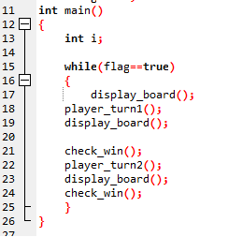

Figure 21: The function is called in the main body

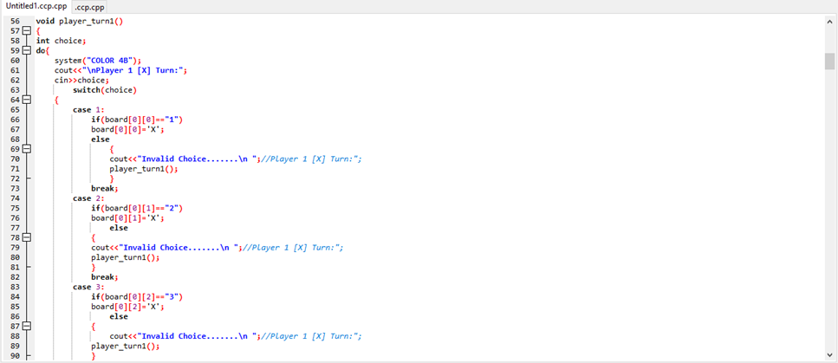

Figure 22: Player turn switch statement cases

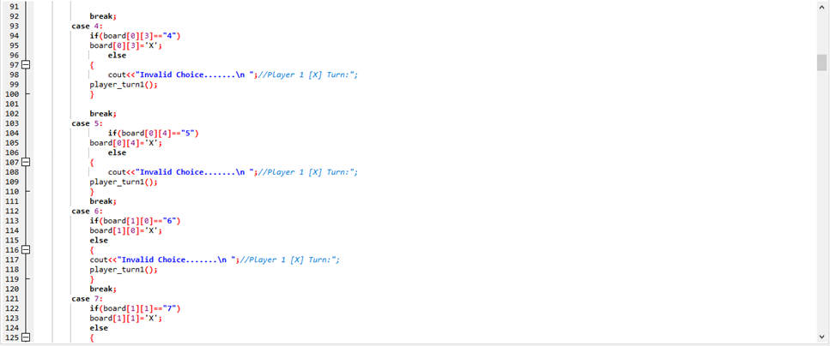

Figure 23: Player turn cases using switch statement

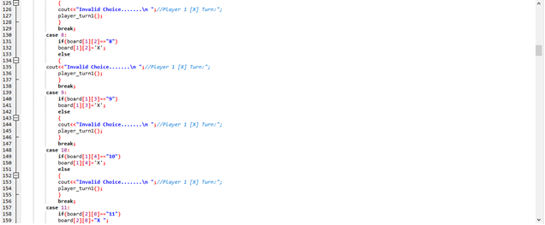

Figure 24: Player turn using switch statement cases

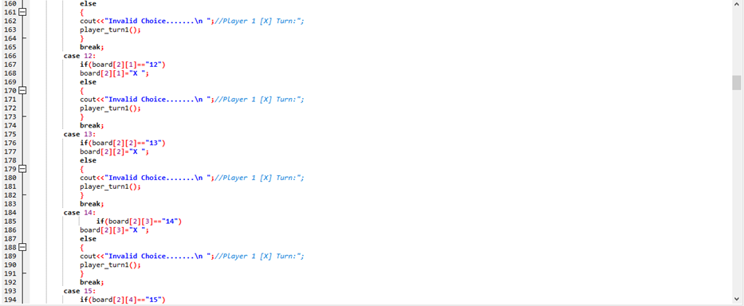

Figure 25:Player turn using switch statement cases

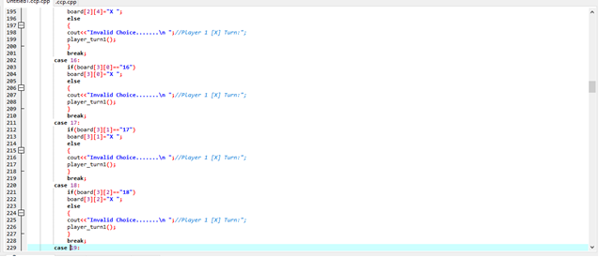

Figure 26: Player turn using switch statement cases

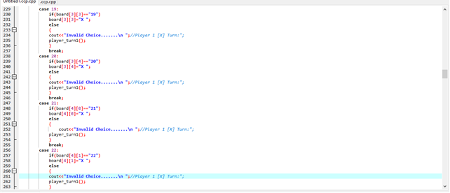

Figure 27 Player turn using switch statement cases

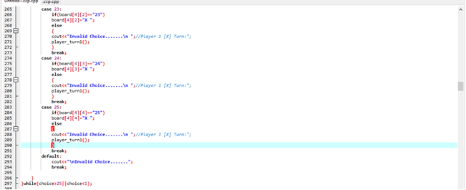

Figure 28: Player turn using switch statement cases

o Function of Player_turn 2

This is the user define function that is used in the making of Tick Cross Game. This type of function is used to decided where the input value is store . For this function we are going to use Switch statement and there are total 25 cases that will decide where the user will input the value and replace the value the numerical value with the Symbol “O”. In order to get again and again the value from the user we will use Do while loop as shown in the figure. First the function is declared as Global Variable and then the function is created and the function is called in the main body as shown in the diagram first the function is created and then call in the main body.



Figure 29:Defining of the function



Figure 30: Calling of the function in the main body

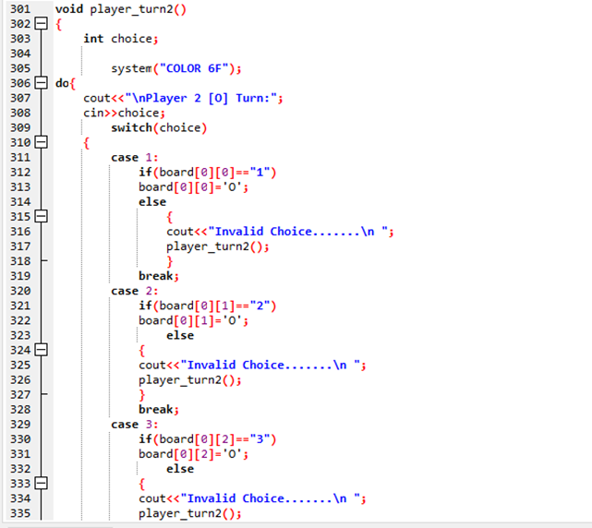

Figure 31: Player turn 2 using switch statement cases

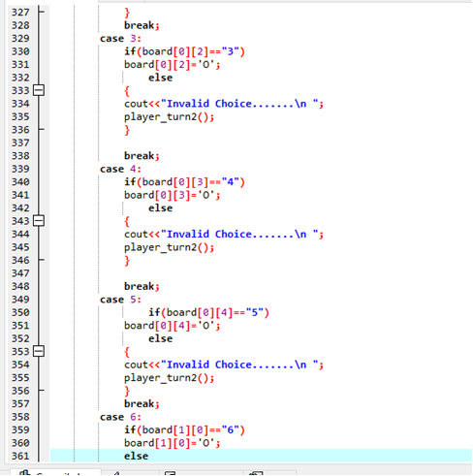

Figure 32Player turn 2 using switch statement cases

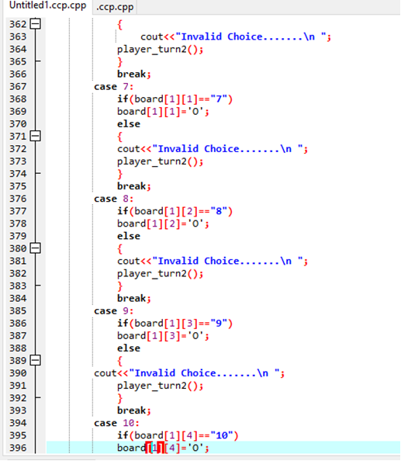

Figure 33: Player turn 2 using switch statement cases